SQL TASK:

1. Exercise - 1

- Find the title of each film
SELECT title FROM movies;
- Find the director of each film
SELECT director FROM movies;
- Find the title and director of each film
SELECT title,director FROM movies;
- Find the title and year of each film
SELECT title,year FROM movies;
- Find all the information about each film
SELECT * FROM movies;

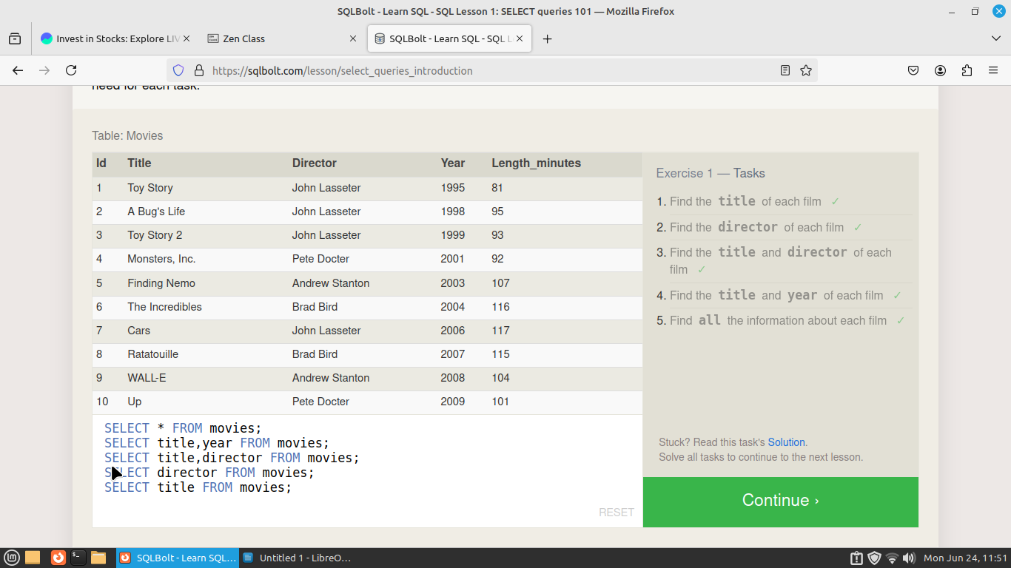
Exercise 2
- Find the movie with a row id of 6
SELECT * FROM movies where id=6;
- Find the movies released in the years between 2000 and 2010
SELECT * FROM movies where year>2000 and year<=2010;
- Find the movies not released in the years between 2000 and 2010
SELECT * FROM movies where year<2000 or year>2010;
- Find the first 5 Pixar movies and their release year
SELECT title,year FROM movies limit 5;
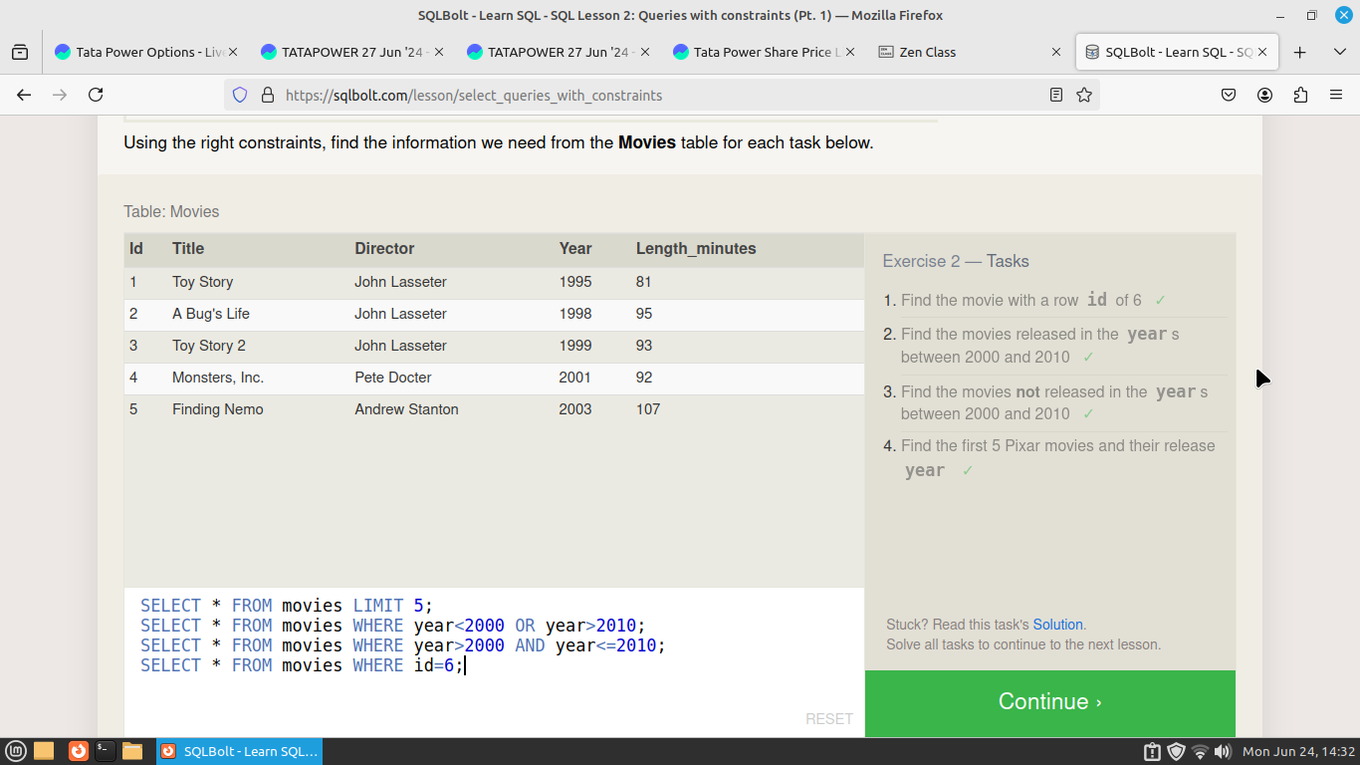

Exercise 3 — Tasks
- Find all the Toy Story movies
SELECT title FROM movies where title like "Toy%";
- Find all the movies directed by John Lasseter
SELECT title FROM movies where director="John Lasseter";
- Find all the movies (and director) not directed by John Lasseter
SELECT title FROM movies where director<>"John Lasseter";
- Find all the WALL-* movies
SELECT title FROM movies where title like "WALL-%";

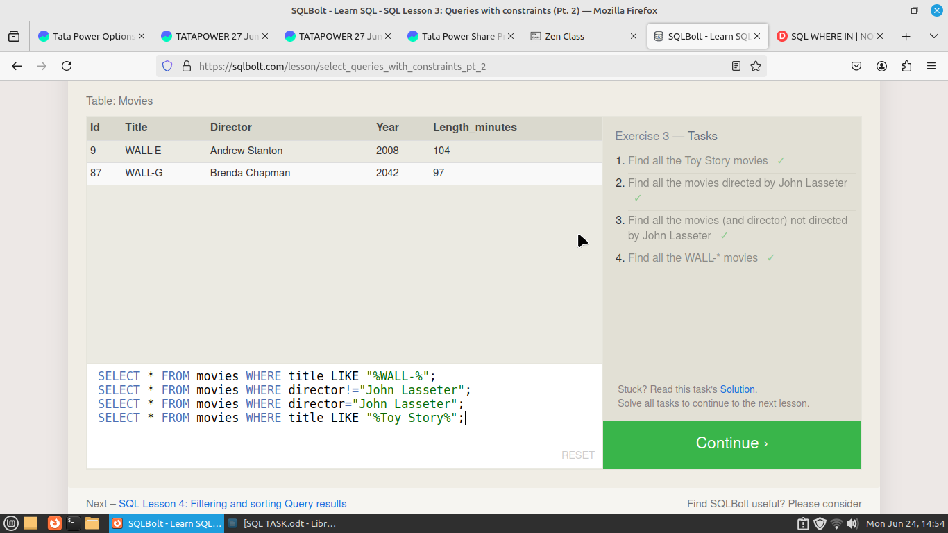
Exercise 4 — Tasks
- List all directors of Pixar movies (alphabetically), without duplicates
SELECT distinct director FROM movies order by director;
- List the last four Pixar movies released (ordered from most recent to least)
SELECT * FROM movies order by year desc limit 4;
- List the first five Pixar movies sorted alphabetically
SELECT * FROM movies order by title limit 5;
- List the next five Pixar movies sorted alphabetically
SELECT * FROM movies order by title limit 5 offset 5;

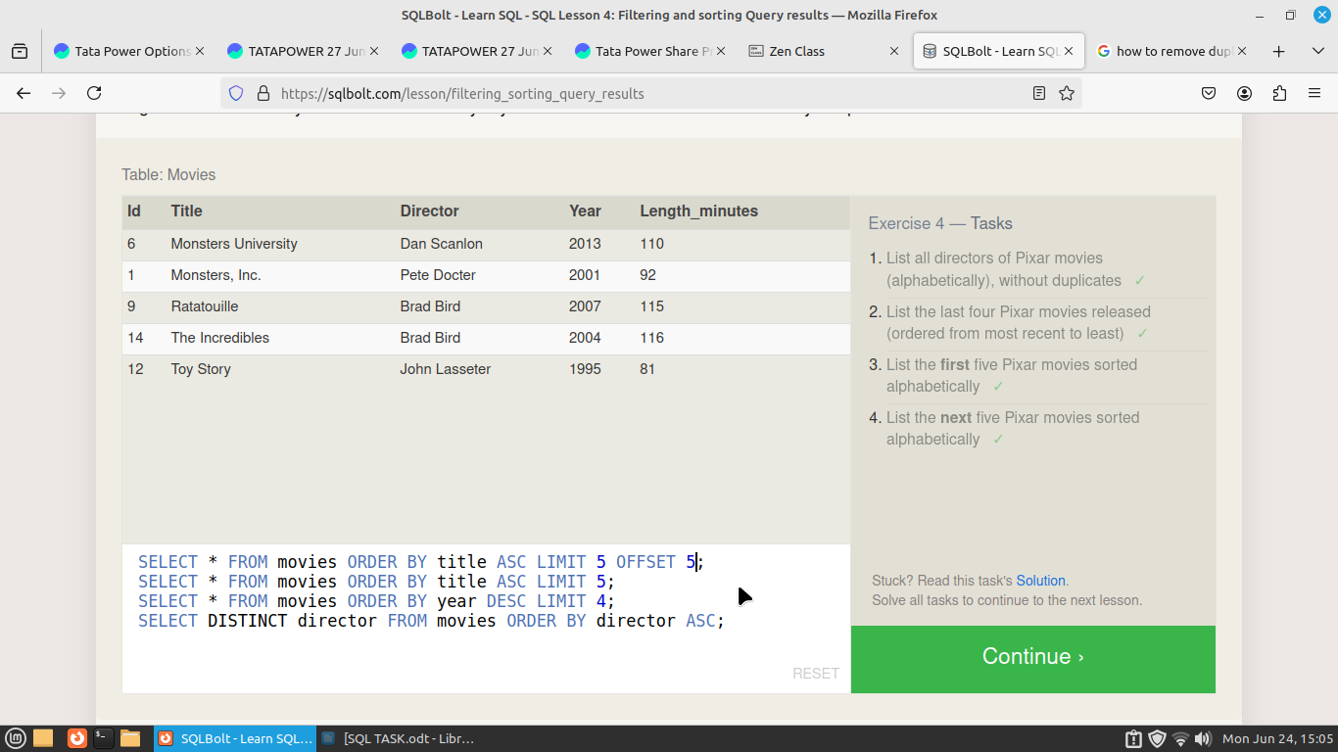

Exercise -5

- List all the Canadian cities and their populations
select city,population from North_american_cities where country="Canada";
- Order all the cities in the United States by their latitude from north to south
select city from North_american_cities where country="United States" order by latitude Desc;
- List all the cities west of Chicago, ordered from west to east
select city from North_american_cities where longitude<-87.69 order by longitude;
- List the two largest cities in Mexico (by population)
select city from North_american_cities where country="Mexico" order by population desc limit 2;
- List the third and fourth largest cities (by population) in the United States and their population
select city from North_american_cities where country="United States" order by population desc limit 2 offset 2;
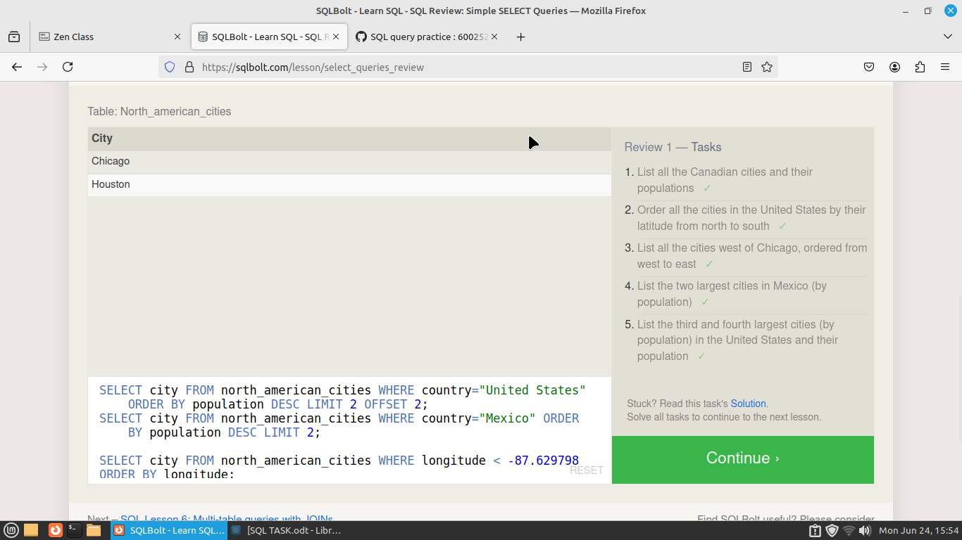
Exercise 6 — Tasks
- Find the domestic and international sales for each movie
SELECT title,domestic_sales,international_sales FROM movies inner join boxoffice on movies.id=boxoffice.movie_id ;
- Show the sales numbers for each movie that did better internationally rather than domestically
SELECT title,domestic_sales,international_sales FROM movies inner join boxoffice on movies.id=boxoffice.movie_id where domestic_sales<international_sales;
- List all the movies by their ratings in descending order
SELECT title,rating FROM movies inner join boxoffice on movies.id=boxoffice.movie_id order by rating desc;
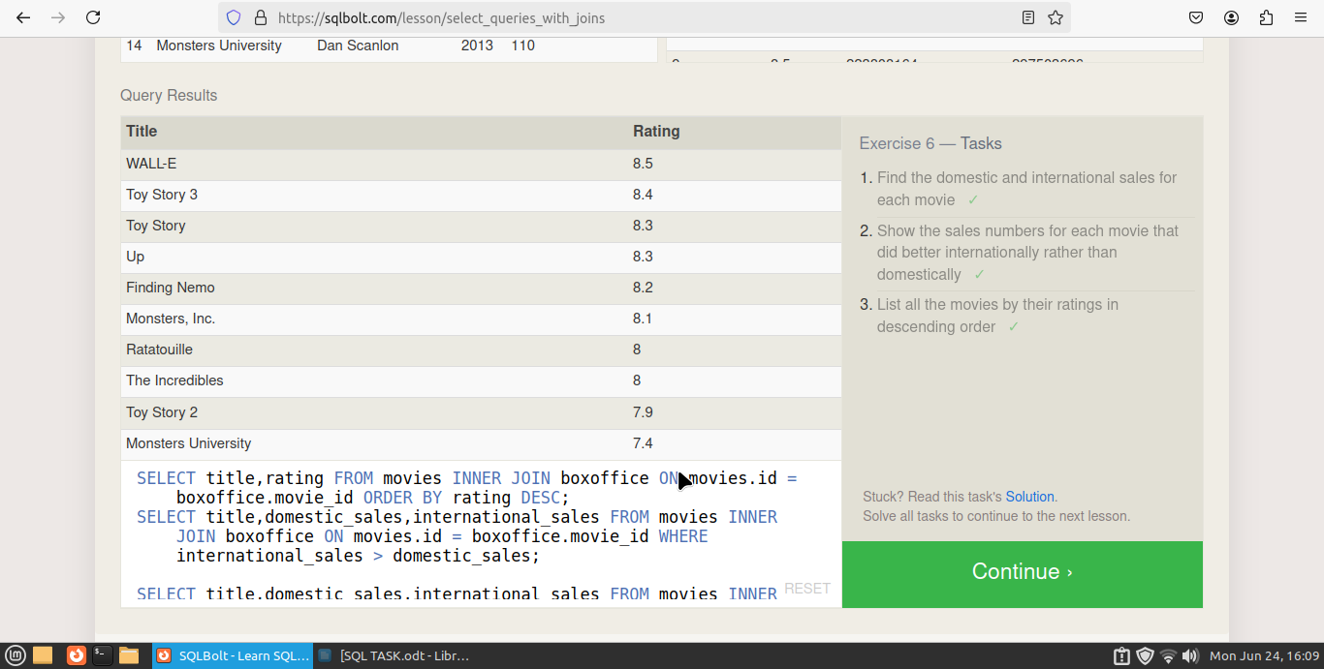
Exercise 7 — Tasks

- Find the list of all buildings that have employees
SELECT distinct building_name FROM buildings left join employees on buildings.building_name=employees.building where name is not null;
- Find the list of all buildings and their capacity
SELECT building_name,capacity FROM buildings;
- List all buildings and the distinct employee roles in each building (including empty buildings)
SELECT distinct building_name,role from buildings left join employees
on buildings.building_name = employees.building;
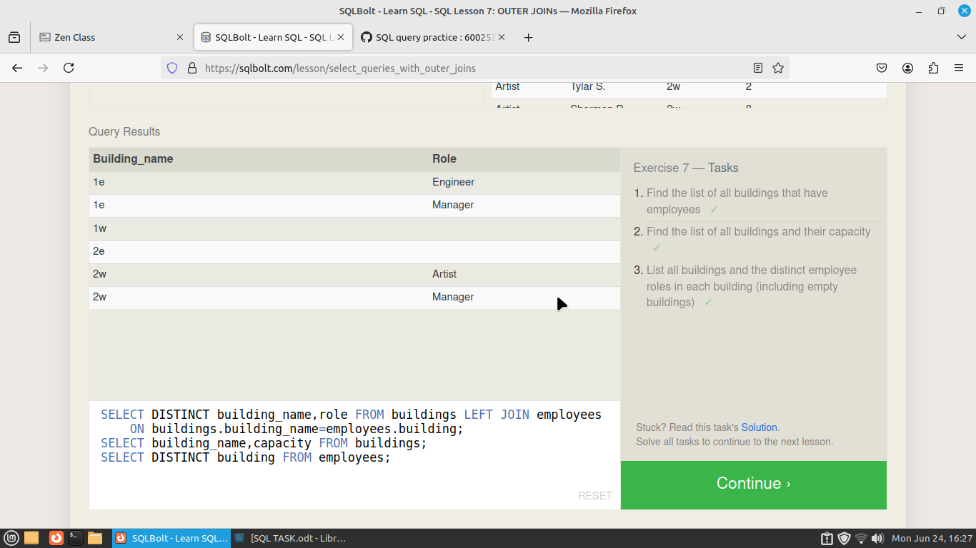
Exercise 8 — Tasks
- Find the name and role of all employees who have not been assigned to a building
SELECT name,role FROM employees left join buildings on
buildings.building_name=employees.building where building is null;
- Find the names of the buildings that hold no employees
select building_name,name from buildings left join employees on
buildings.building_name = employees.building where name is null;

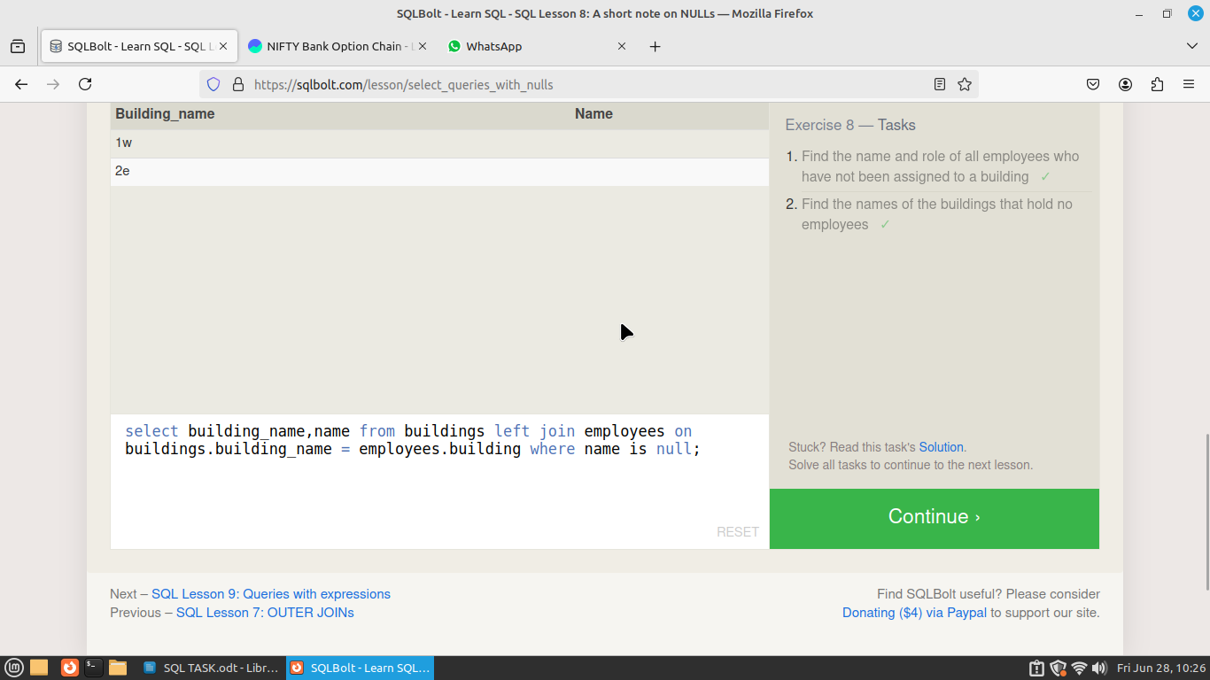
Exercise 9 — Tasks

- List all movies and their combined sales in millions of dollars
SELECT title,(domestic_sales+international_sales)/100000[combined sales] FROM movies inner join boxoffice on movies.id=boxoffice.movie_id;
- List all movies and their ratings in percent
SELECT title,(rating*10)[ratings percentage] FROM movies inner join boxoffice on movies.id=boxoffice.movie_id;
- List all movies that were released on even number years
SELECT title,year from movies where year%2=0;
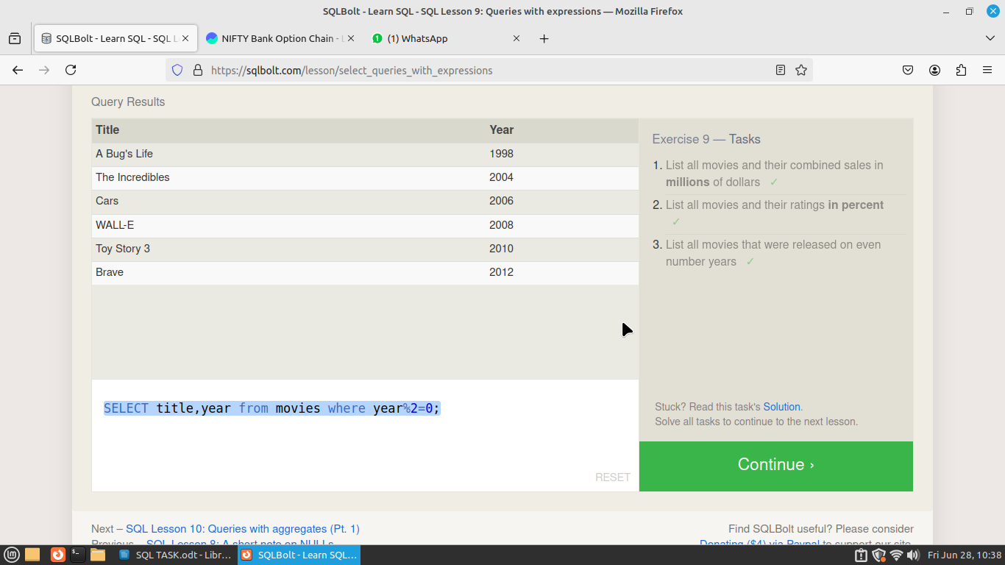

Exercise 10 — Tasks
- Find the longest time that an employee has been at the studio
SELECT name,max(years_employed) FROM employees;
- For each role, find the average number of years employed by employees in that role
SELECT role,avg(years_employed)as [work experience] FROM employees group by role;
- Find the total number of employee years worked in each building
SELECT building,sum(years_employed) as [total no emp exp] FROM employees group by building;
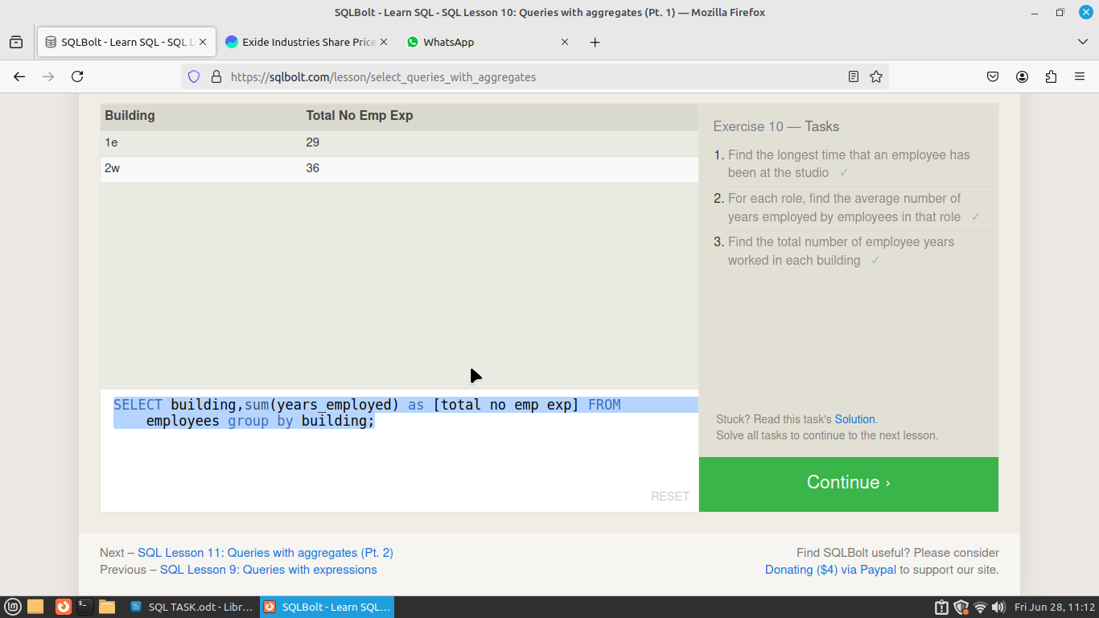

Exercise 11 — Tasks

- Find the number of Artists in the studio (without a HAVING clause)
SELECT role,count(role)as[count] FROM employees where role is "Artist";
- Find the number of Employees of each role in the studio
SELECT role,count(name) FROM employees group by role;
- Find the total number of years employed by all Engineers
SELECT role,sum(years_employed) FROM employees where role is 'Engineer';
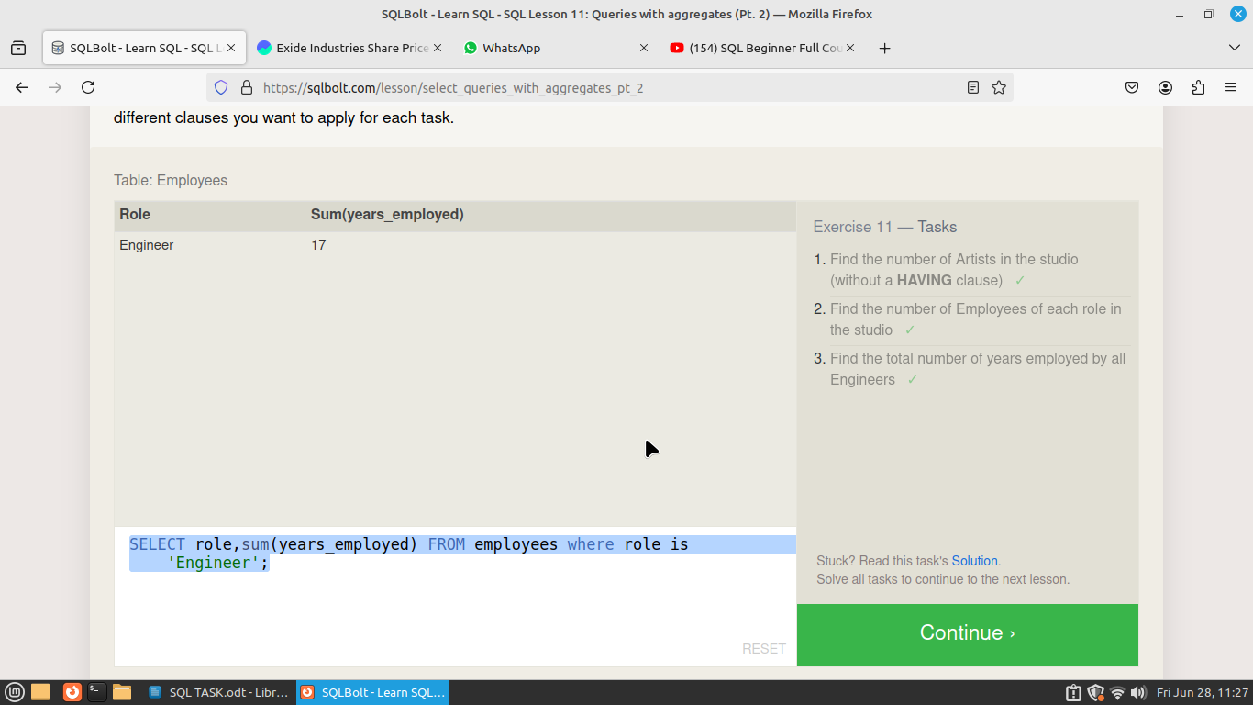
Exercise 12 — Tasks
- Find the number of movies each director has directed
SELECT director,count(title)as[no movies] FROM movies group by director;
- Find the total domestic and international sales that can be attributed to each director
select director,(domestic_sales+international_sales)as [total sales] from movies left join boxoffice on movies.id=boxoffice.movie_id group by director ;
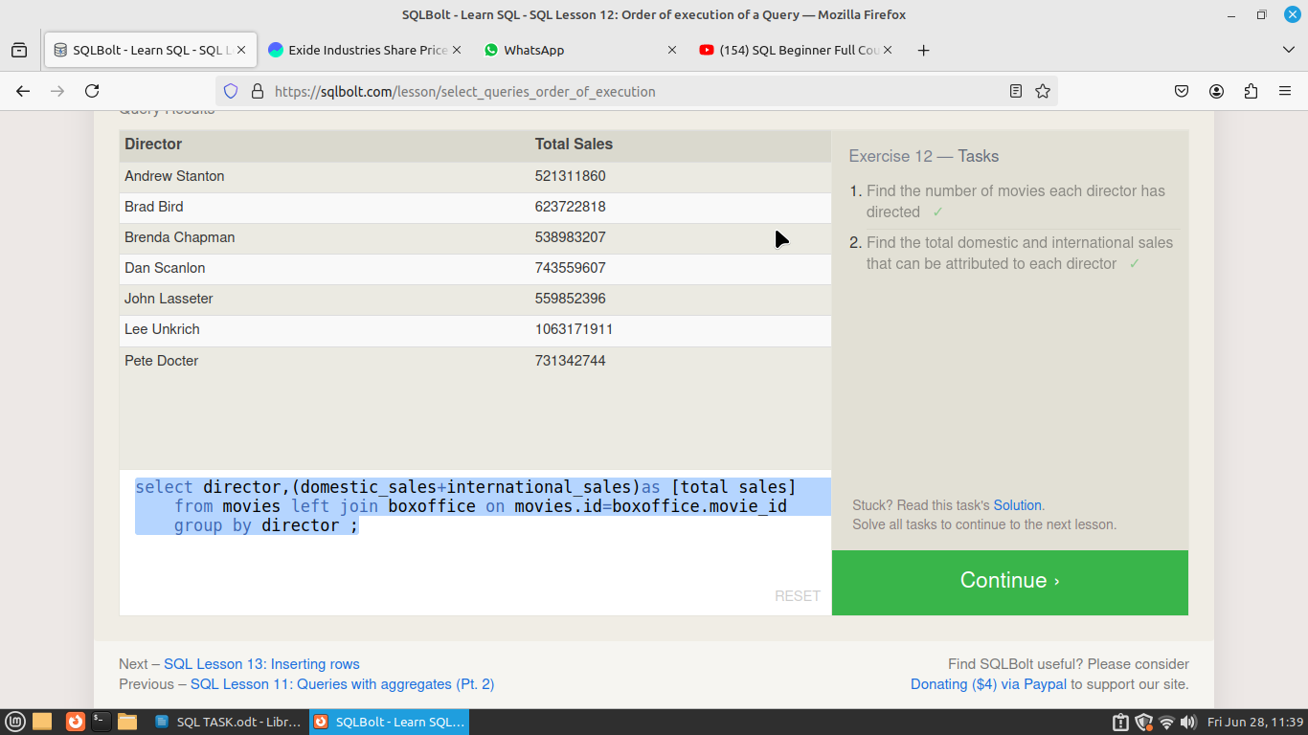

Exercise 13 — Tasks
- Add the studio's new production, Toy Story 4 to the list of movies (you can use any director)
INSERT INTO movies (id,title,director,year,length_minutes)values(15,'Toy Story 4','John Lasseter','2014',102);
- Toy Story 4 has been released to critical acclaim! It had a rating of 8.7, and made 340 million domestically and 270 million internationally. Add the record to the BoxOffice table.
insert into boxoffice (movie_id,rating,domestic_sales,international_sales)values(15,8.7,340000000,270000000);

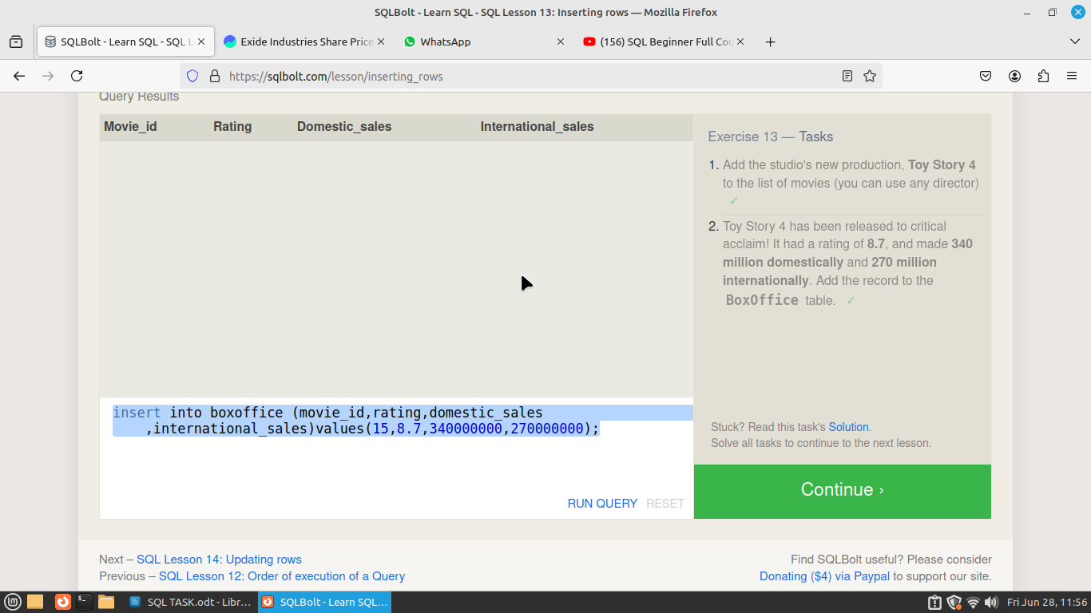
Exercise 14 — Tasks

- The director for A Bug's Life is incorrect, it was actually directed by John Lasseter
update movies set director="John Lasseter" where id=2;

- The year that Toy Story 2 was released is incorrect, it was actually released in 1999
update movies set year="1999" where id=3;

- Both the title and director for Toy Story 8 is incorrect! The title should be "Toy Story 3" and it was directed by Lee Unkrich
update movies set title="Toy Story 3",director="Lee Unkrich" where id=11;

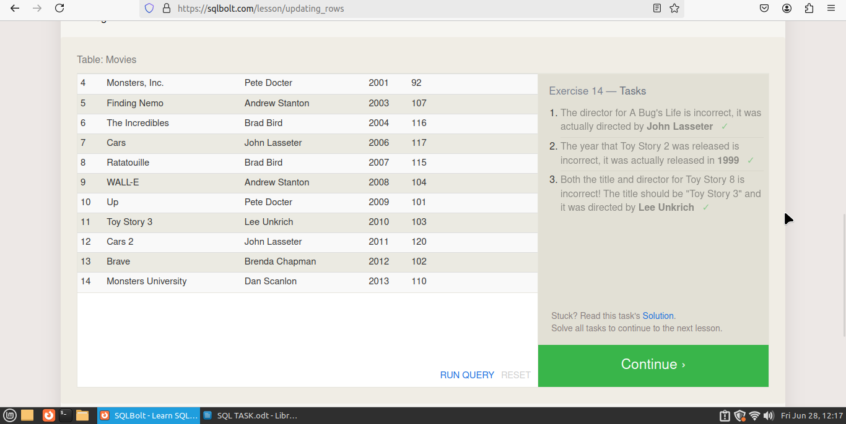
Exercise 15 — Tasks
- This database is getting too big, lets remove all movies that were released before 2005.
DELETE from movies where year<2005;
- Andrew Stanton has also left the studio, so please remove all movies directed by him.
DELETE FROM movies where director="Andrew Stanton";
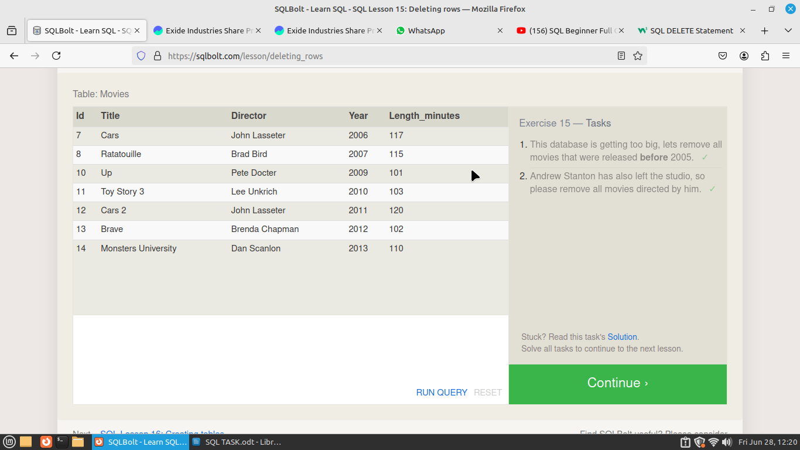

Exercise 16 — Tasks
- Create a new table named Database with the following columns:
– Name A string (text) describing the name of the database
– Version A number (floating point) of the latest version of this database
– Download_count An integer count of the number of times this database was downloaded
This table has no constraints.
CREATE table Database (Name text ,Version float,Download_count int);
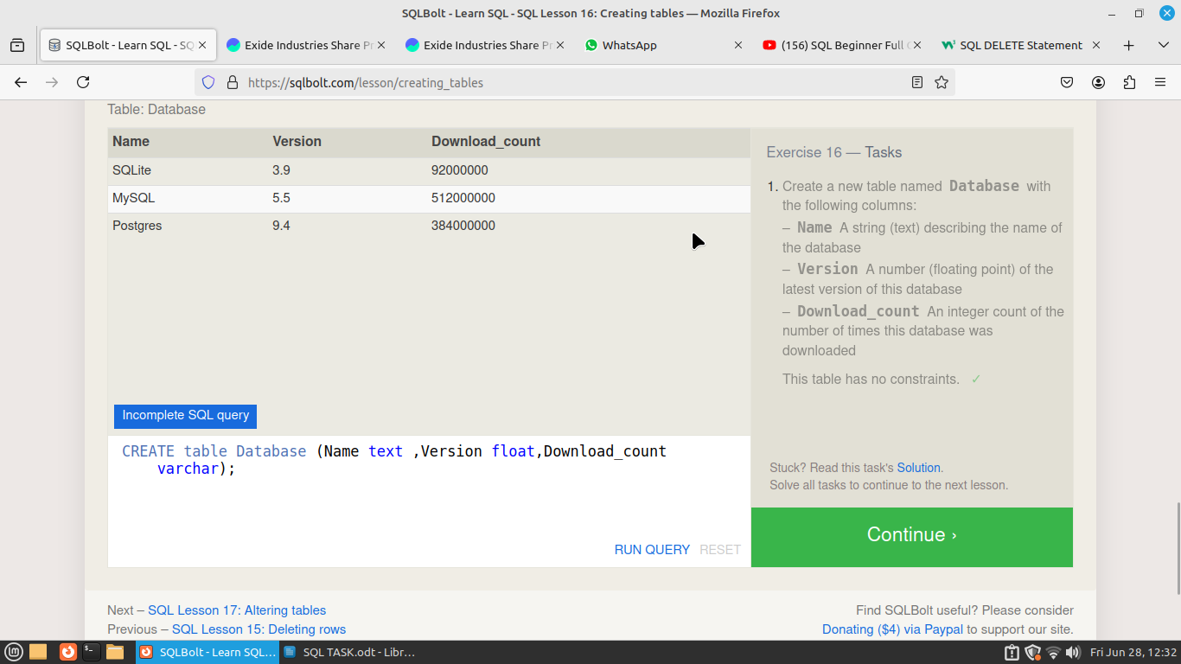
Exercise 17 — Tasks
- Add a column named Aspect_ratio with a FLOAT data type to store the aspect-ratio each movie was released in.
ALTER TABLE movies add Aspect_ratio float;
- Add another column named Language with a TEXT data type to store the language that the movie was released in. Ensure that the default for this language is English.
ALTER TABLE movies add Language text default 'english';
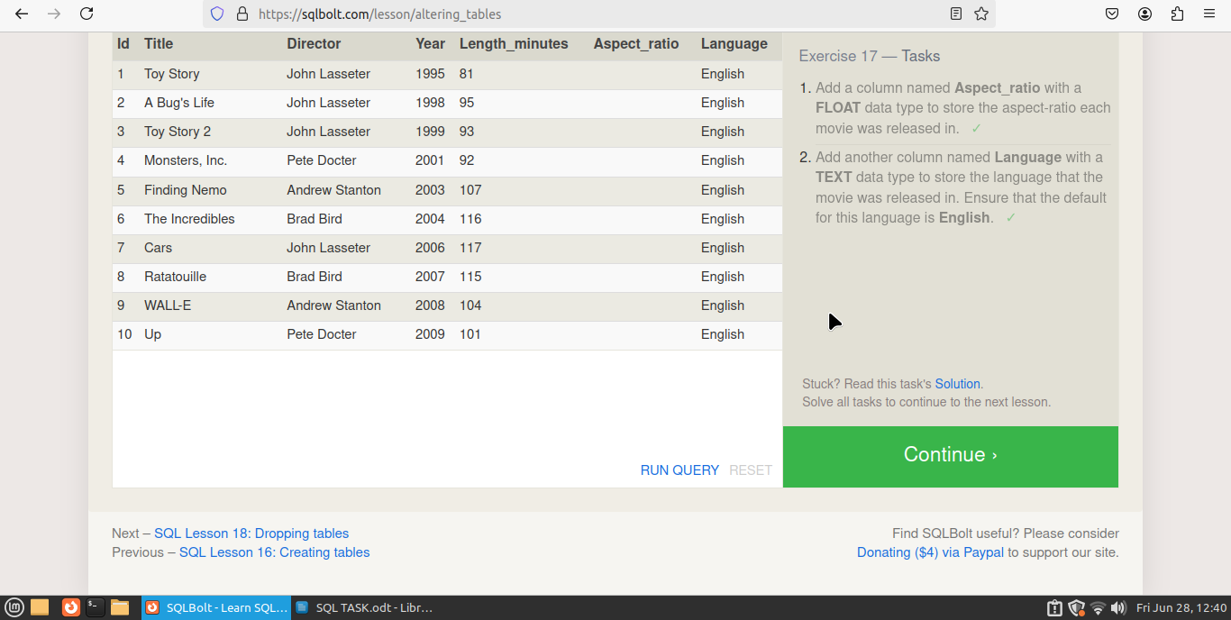
Exercise 18 — Tasks
- We've sadly reached the end of our lessons, lets clean up by removing the Movies table
DROP TABLE movies;
- And drop the BoxOffice table as well
DROP TABLE boxoffice;
